Assignment 17.5

Write a map reduce program to using a custom counter to count number of people are affected with 'PULMONARY' disease and 'BRONCHITIS & ASTHMA' in the state 'CA'.

Driver class:

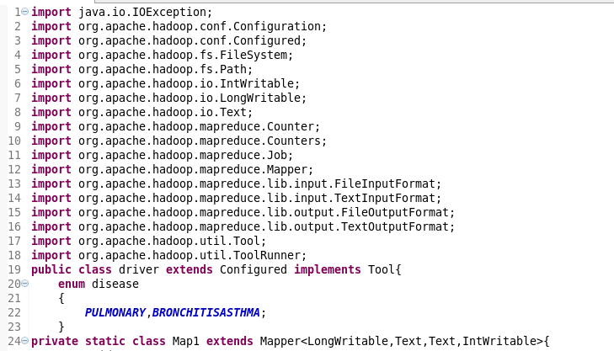

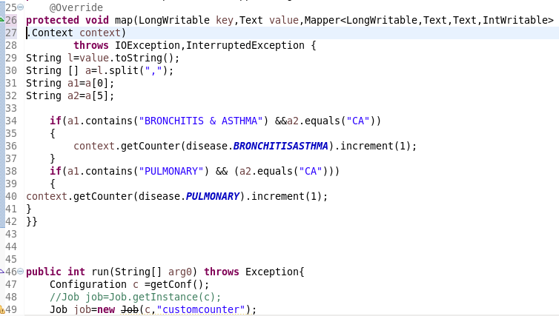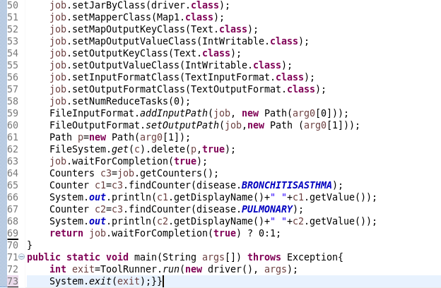

The custom counter BRONCHITIS and PULMONARY has been created and incremented.

Output:

Here, it is showing the count.

